README FOR GIT USAGE

Internship Project

Srivatsava Gummalla, 140905292

27-June-2017

1. Download the latest [Git for Windows installer](https://git-for-windows.github.io/).
2. When you've successfully started the installer, you should see the **Git Setup** wizard screen. Follow the **Next** and **Finish** prompts to complete the installation. Use default options.
3. Open a Command Prompt (or Git Bash if during installation you elected not to use Git from the Windows Command Prompt).
4. Run the following commands to configure your Git username and email using the following commands, replacing Emma's name with your own. These details will be associated with any commits that you create: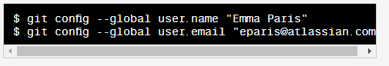
5. Type git init in the command line at the location of the repository. This creates a new subdirectory named .git that contains all of your necessary repository files – a Git repository skeleton.
6. 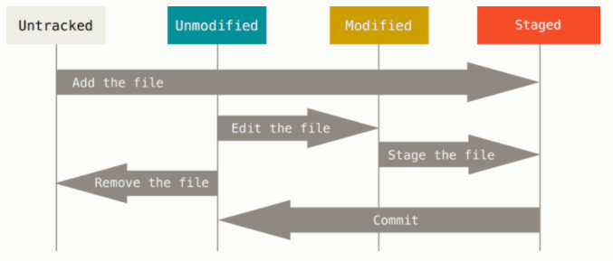Status of files in the git repository:-
7. Install TortoiseGit for windows from <https://tortoisegit.org/download/>

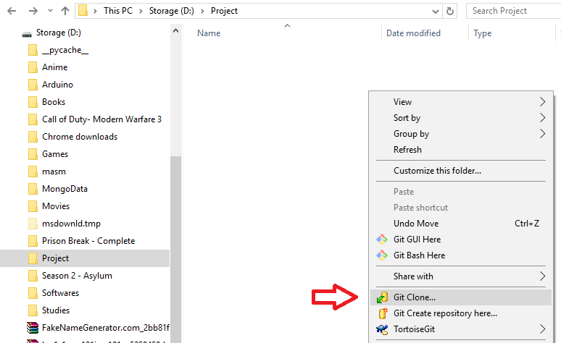

1. Go to the directory where the repository needs to be cloned and select the Git Clone in the right click drop down menu.

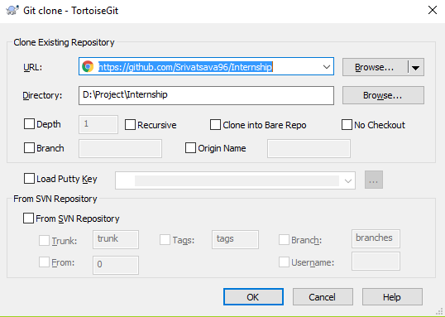

1. In the URL field enter the URL of the git repository which can be taken from here :

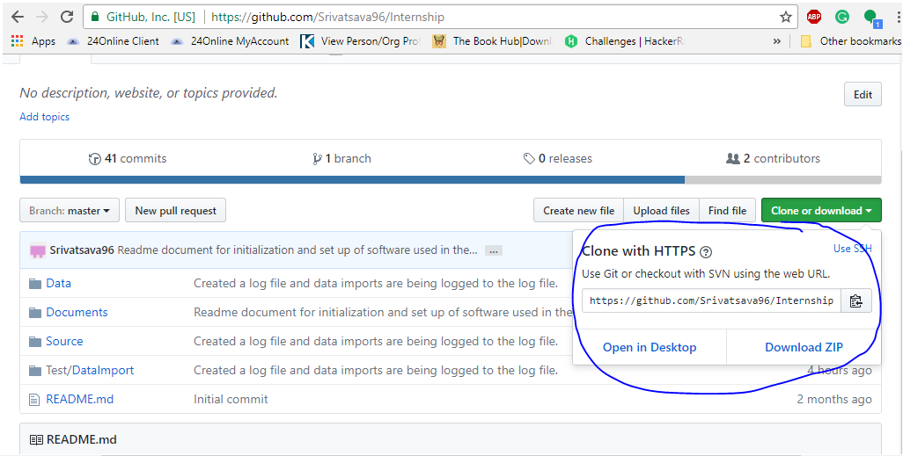

1. To add a new file to the repository, select the file which is placed in the local directory and right click on it. Select the TortoiseGit and click on Add.
2. To commit the modified file and upload/check-in to the repository right click in the local directory and select the Git commit 🡪 master option from the drop-down menu.
3. Select the modified files to be committed and write the comments. Click on commit.
4. After committing click on push to upload the files to the global repository.
5. To update the local repository, select the Pull option from the right click drop down menu in the TortoiseGit option.
6. To resolve conflicts, refer Git help.

